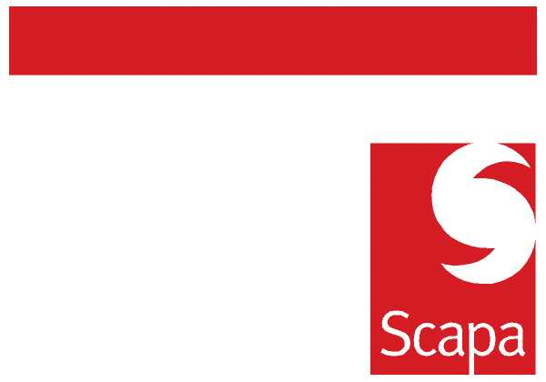
ORGANISATIONAL ANNOUNCEMENT

As previously announced, the next step in the reorganisation is the formation of Global Business Units (GBUs). The new commercial structure will further focus and emphasise our efforts in the key markets of Medical, Electronics, Industrial, Transport and Consumer. The GBUs will be responsible for the strategy and resources of the respective market on a global basis. The GBUs will also be responsible for the technology, product and pricing roadmap.
I am pleased to announce the following appointments to lead the Global Business Units:
- Medical: Barry Andrew
- Transport: Barry Andrew
- Electronics (Asia): Gene Kim
- Industrial : Mike Muchin
Given the unique regional requirements of the market, the Consumer BU will continue to operate on a regional basis under Marc Fournier for Europe and Rakesh Kumar for North America. The Emerging Markets will be combined with the Industrial GBU to provide the necessary resources and scale. Scott Barnes and Chris Wren will report to Mike Muchin. Additionally, Daniel Ephgrave will head the European Industrial BU reporting to Mike Muchin. Barry will shortly announce the plan for Medical Europe.
I am also pleased to announce the appointment of Paul Botsford as Director of Sales, Europe, with effect from Monday, 17 May 2010. Paul will be responsible for outside sales, inside sales and customer service in Europe. Paul will also have dotted line responsibility for the strategic account managers in the BUs. Paul joins us from GE where he has held various sales leadership positions during the past 11 years.
Troy Asberry who joined Scapa in April as Director of Sales, North America will have the same responsibility for North America. Troy has held various sales leadership roles at Volex Group and Amphenol Corp during the past 10 years.
The GBU General Managers and Directors of Sales will report to Director of Global Sales who will be a member of the Corporate Executive Team. We are currently conducting an executive search to recruit an individual from outside. In the interim, the positions will report to me.
During the last seven months, we have gone through significant changes in direction, focus, structure and culture. I am excited at the positive impact they have had in the organisation. It reinforces my belief that we are doing the right things. The best validation is the results. We have returned to cash generation and profitability. The booking and expected revenue for the first month is exceeding budget. Thank you everyone for all your efforts.

Heejae Chae
April 28, 2010

